**DAILY ONLINE ACTIVITIES SUMMARY**

|  |  |  |  |  |  |  |  |
| --- | --- | --- | --- | --- | --- | --- | --- |
| **Date:** | **04-07-2020** | | | | **Name:** | **B.A.SOHANKUMAR** | |
| **Sem & Sec** | **4TH SEM A** | | | | **USN:** | **4AL18CS013** | |
| **Online Test Summary** | | | | | | | |
| **Subject** | | **----** | | | | | |
| **Max. Marks** | | **----** | | **Score** | | **----** | |
| **Certification Course Summary** | | | | | | | |
| **Course** | **STATISTICS FOR DATA SCIENCE** | | | | | | |
| **Certificate Provider** | | | **GLA** | **Duration** | | | **7.2 HOURS** |
| **Coding Challenges** | | | | | | | |
| **Problem Statement:1.**Given an array of integer arr[] and an integer k, the task is to find the median of each window of size k starting from the left and moving towards the right by one position each time. | | | | | | | |
| **Status: EXECUTED** | | | | | | | |
| **Uploaded the report in Github** | | | | **YES** | | | |
| **If yes Repository name** | | | | **LOCKDOWN CODING** | | | |
| **Uploaded the report in slack** | | | | **YES** | | | |

**CERTIFICATION COURSE DETAILS:**

Course: Statistics for data science

Completed modules today are Probability for Machine Learning,HIV Test case and using Bayes theorem,Spam Not Spam problem and using Bayes theorem,Binomial Distribution,Poisson Probability Function,Normal Distribution,Normal Distribution Function and successfully completed the course.

 

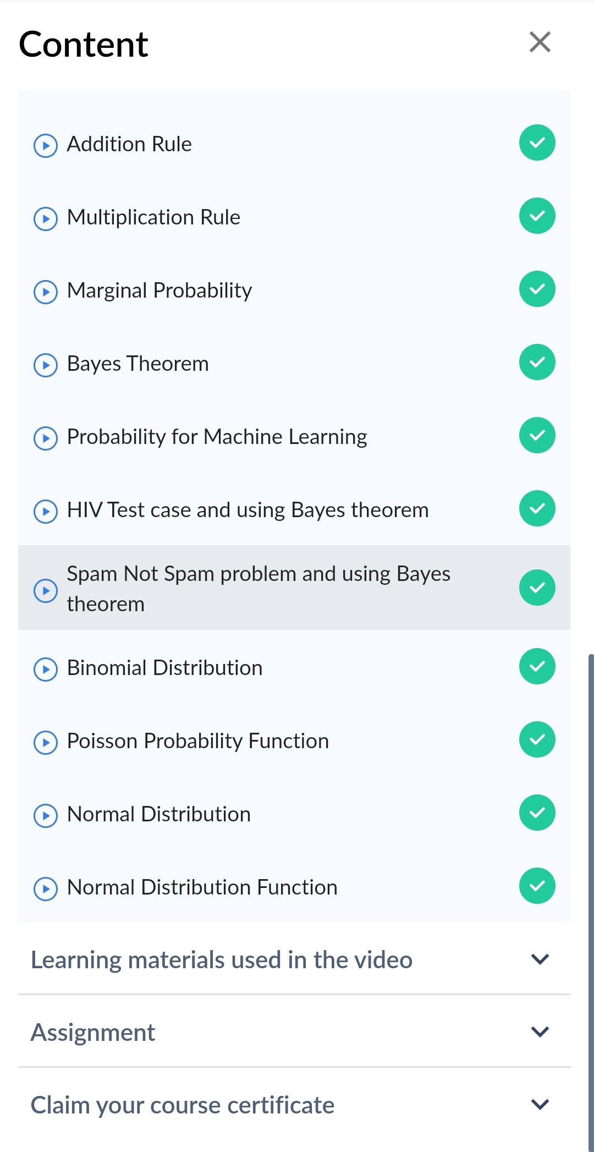COMPLETED TOPICS

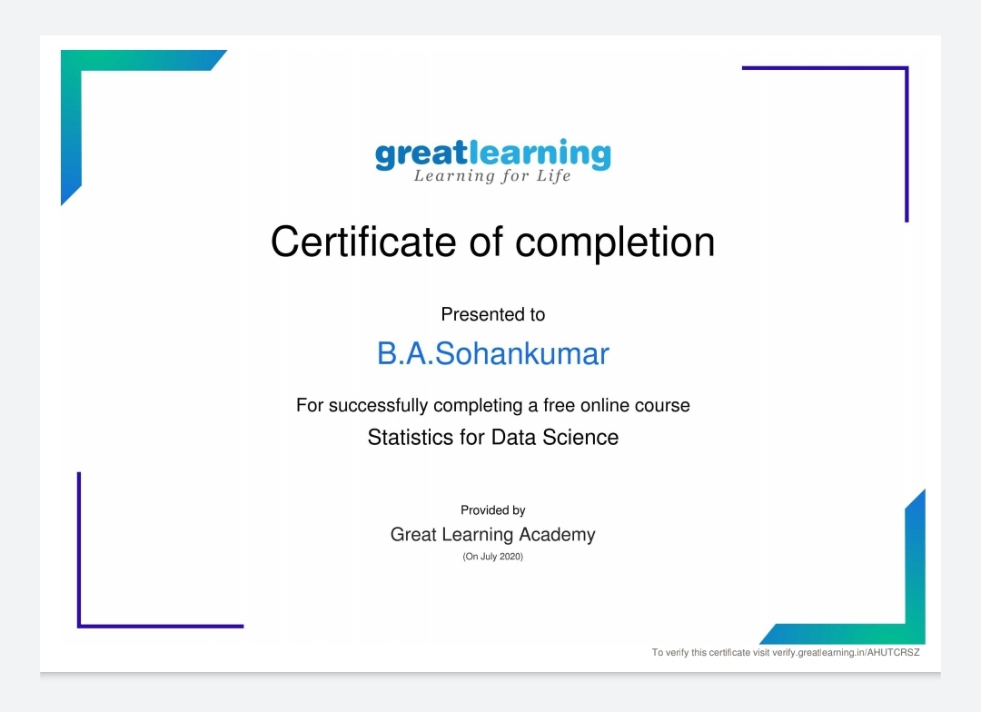

Above certificate is awarded for the completion of this course.

**CODING CHALLENGES DETAILS:**

1.Given an array of integer arr[] and an integer k, the task is to find the median of each window of size k starting from the left and moving towards the right by one position each time.

Examples: Input: arr[] = {-1, 5, 13, 8, 2, 3, 3, 1}, k = 3 Output: 5 8 8 3 3 3 Input: arr[] = {-1, 5, 13, 8, 2, 3, 3, 1}, k = 4 Output: 6.5 6.5 5.5 3.0 2.5

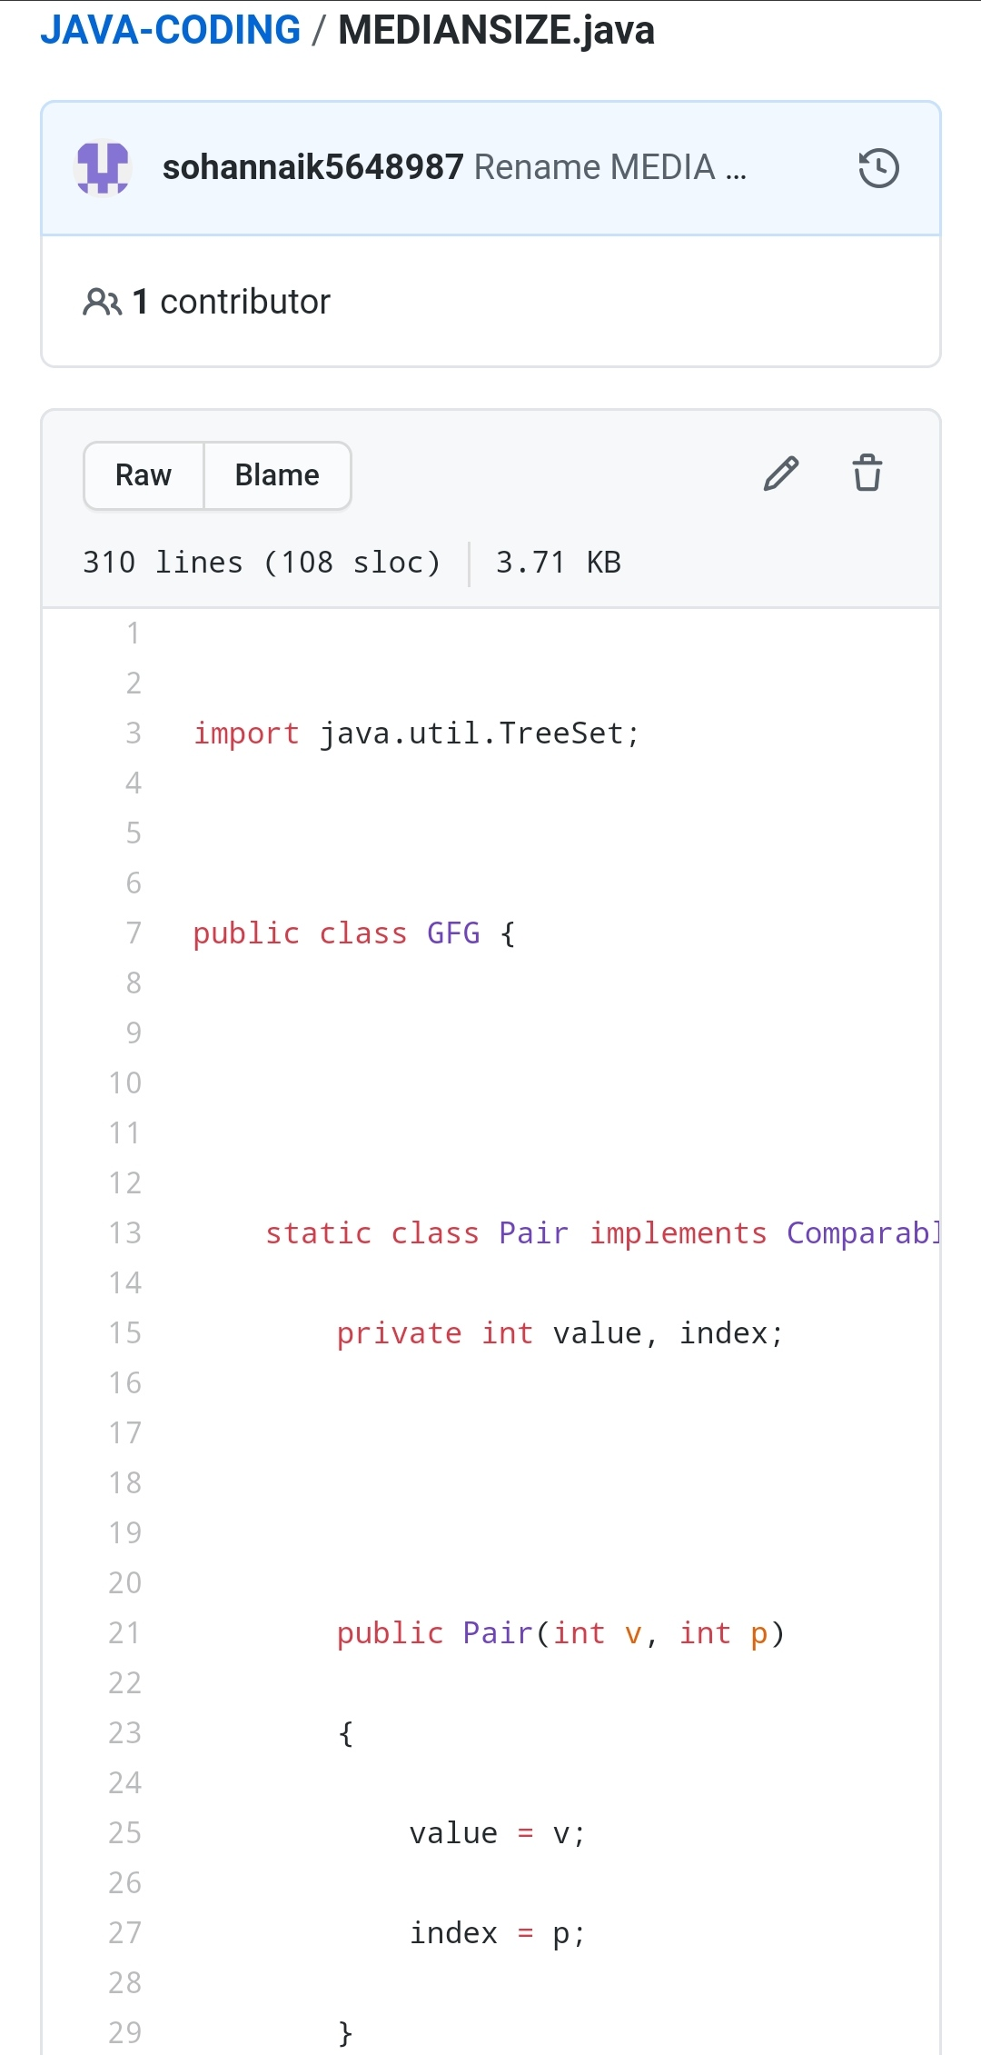

REPOSITORY LINK:https://github.com/sohannaik5648987/JAVA-CODING